**Goos-Hanchen Larmor Experiment Log (updated 12/4/23)**

11/14 (Tuesday) – 11/20 (Monday)

**11/14 Day One (Tuesday)**

* 9:30  
* We decided that the magnetization of the sample will probably not be a problem because the sample is so thin. Therefore we will not worry about the mismatch of the sample field direction and the guide field direction.  
* Still need to magnetize the sample today and finish the sample holder.

* 2:00  
* Found the echo before lunch, need to finish building the sample holder and check the echo as we scan the sample stage (should only need a few mm of drive)  
* Should we use a supermirror or a blank for tuning echo? (decided to just use blank)  
* Aligning the sample slit with the transmission monitor

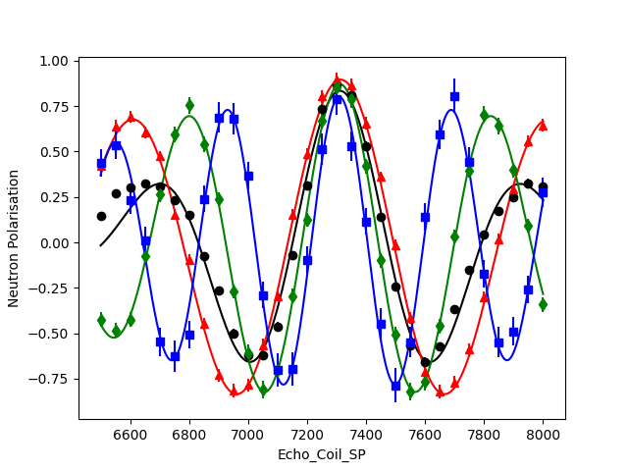

* 7:00  
* Decided to run echo scans overnight to test the long-term stability of the echo point because we cannot retune the echo once we put the magnetic sample in the beam. Also included a scan of the sample stack translation.

**11/15 Day Two (Wednesday)**

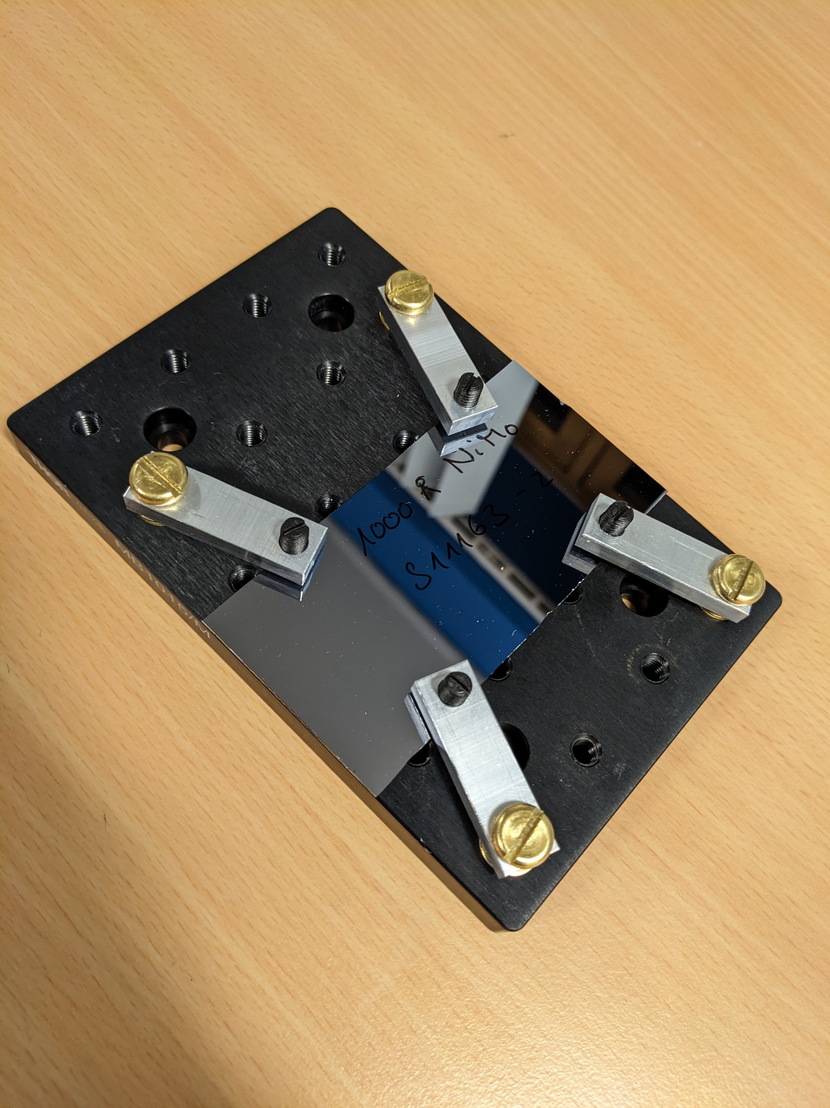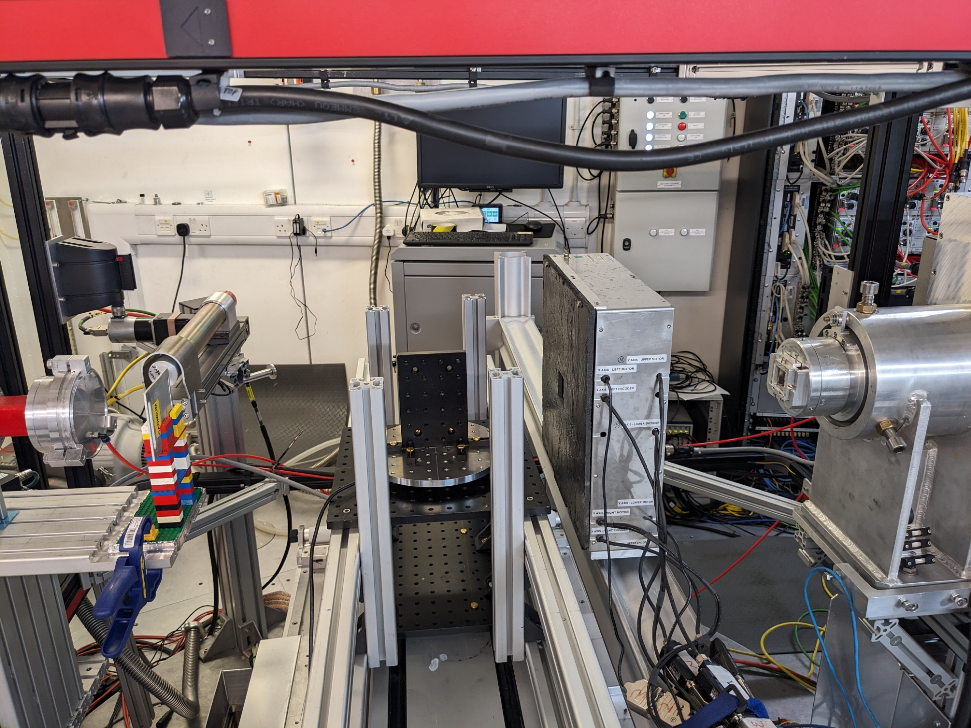* 10:30  
* Echo stability was very stable overnight for all positions of the sample stack. Above 80% for 3-10 AA.  
* Leveled the sample stack (+/- 0.1 degrees for both directions)  
* Adjusted the sample center of rotation to be the same center of rotation of the second arm (within few cms).  
* Finding the center of the beam using a piece of Cd taped to the Al sample holder  
* By eye using laser, the center is at 27 mm and 58.25 degrees  
* Laser beam and neutron beam are off by 0.4 mm using the monitor right after the sample position (center 26.6 mm using neutrons, add 0.8 mm to include the thickness of the sample)  
* Increasing the beam height did not change the tune (25 mm at the front, 40 mm at the sample)  
* Collimation from pipe 31 mm  
* Snout aperture 30 mm height 30 mm width (yes, it is that wide)

* 11:00  
* Pixel 34 is the center of the beam at the moment (0.64 mm per pixel)  
* 41004,41005 are the spectra numbers

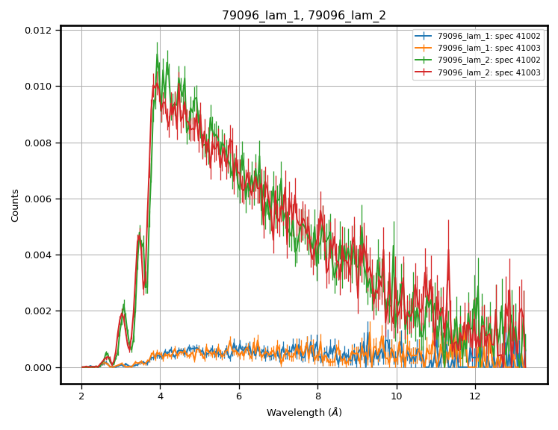

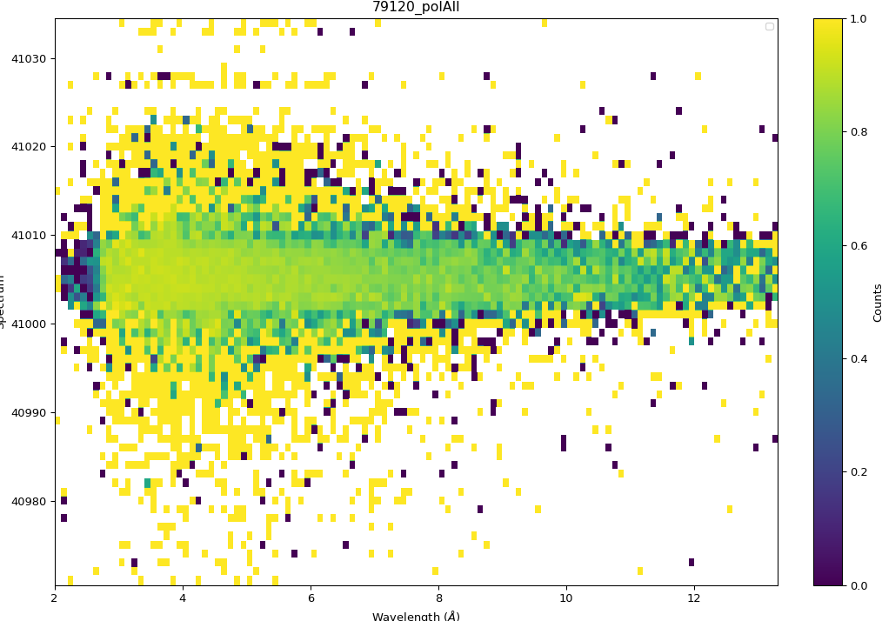* 1:00  
* Magnetized the sample, wrote the field direction on the Al plate. Went to above 0.027 Tesla  
* Found the critical edge to be at 0.35 degrees (aiming for 0.4 degrees?)

* 3:00  
* The blank appears to be curved? The beam is spread over 8 pixels instead of 4 as before.

* 5:00  
* Aperture width is still 2 mm wide  
* Magnetic sample agrees well with Victor's model assuming 89% magnetization. This value agrees more closely with the   
* Going to measure the magnetic sample overnight

**11/16 Day Three (Thursday)**

* 10:00  
* Magnetic sample ran successfully overnight. Improving statistics on the blank until after lunch.

* 8:00  
* Magnetic sample rotated by 90 degrees replicated the original polarization except now the signal is cos(phi) instead of 1/2*(1 + cos(phi))  
* Going to run this orientation overnight and add the grating in tomorrow

Sample with magnetization perpendicular to the guide field.

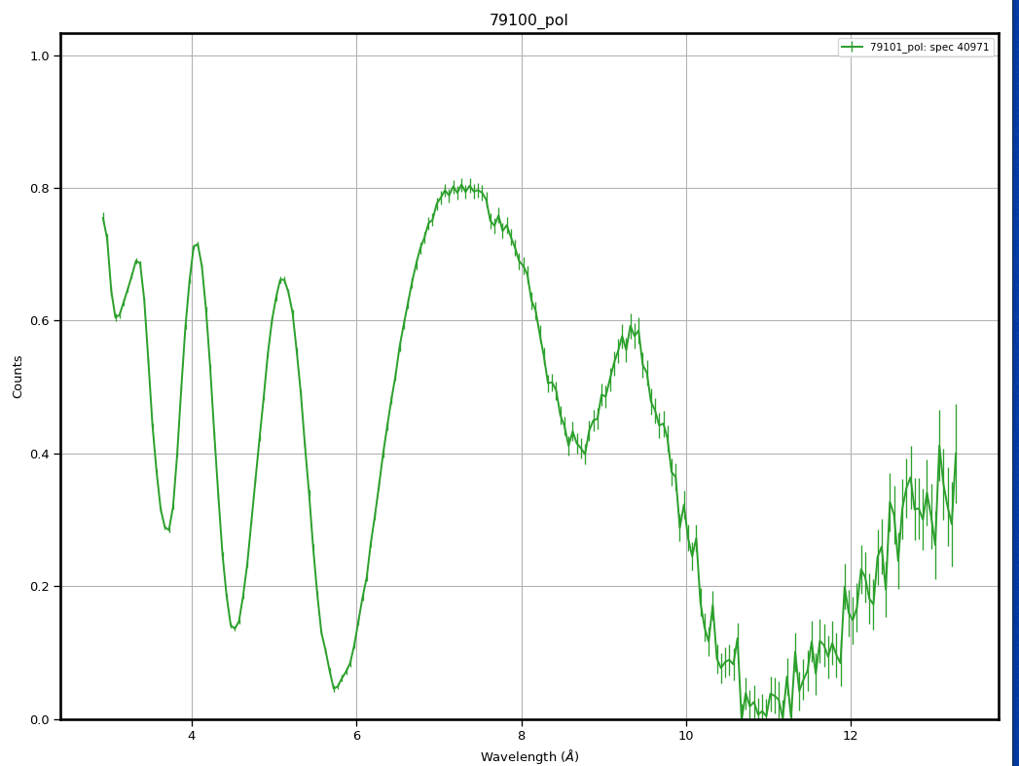

Sample with magnetization parallel to the guide field.

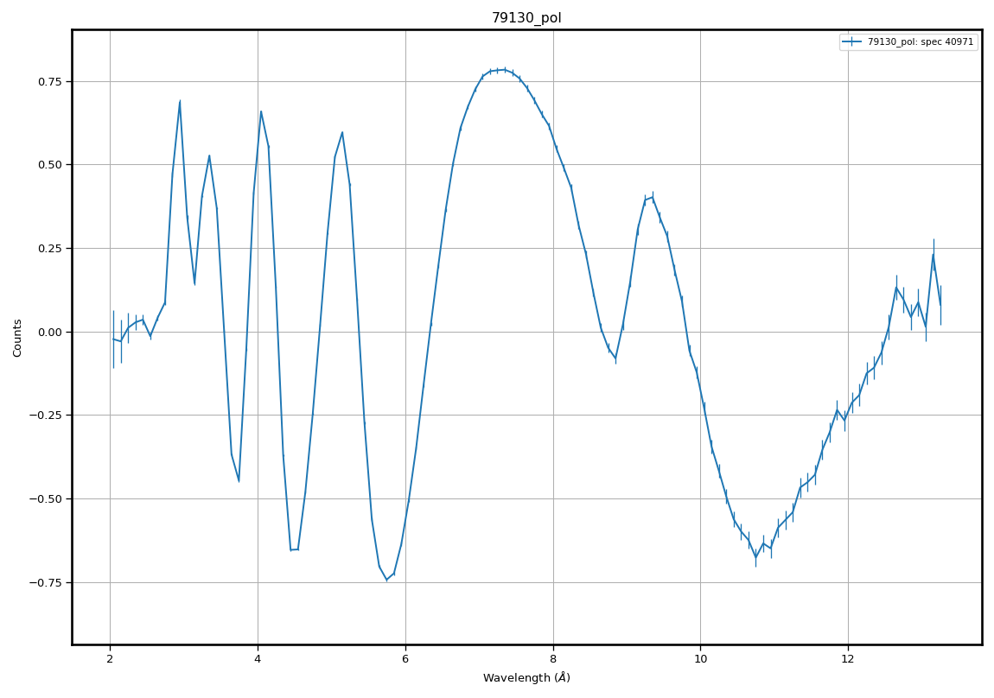

Example of entire detector.

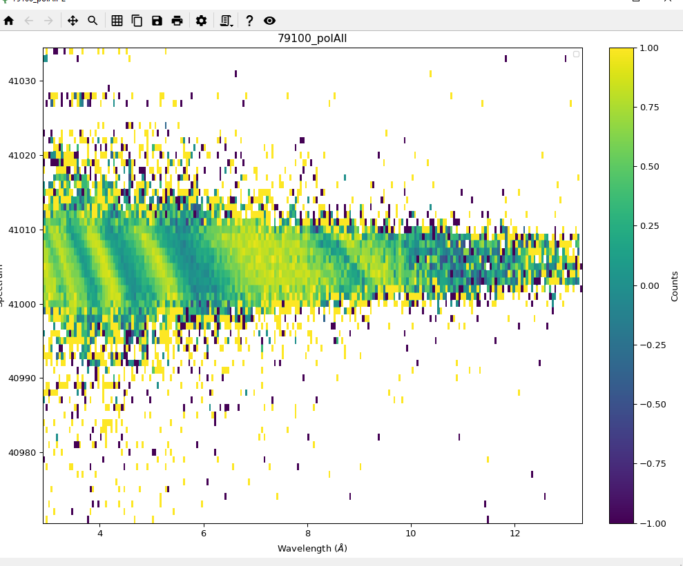

Sample with magnetization perpendicular to the guide field.

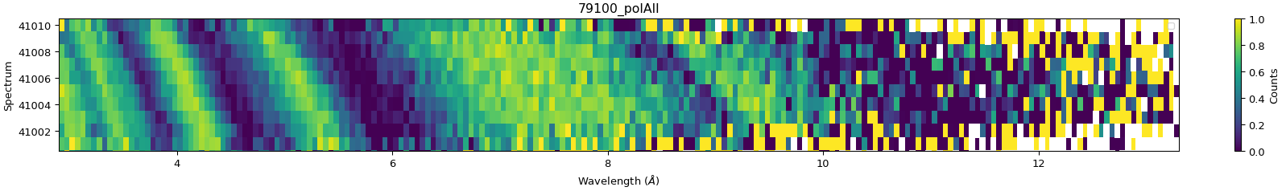

Sample with magnetization parallel to the guide field.

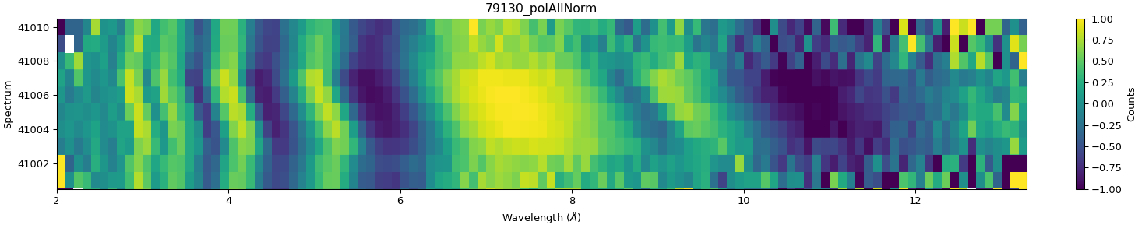

P0 fit with blank.

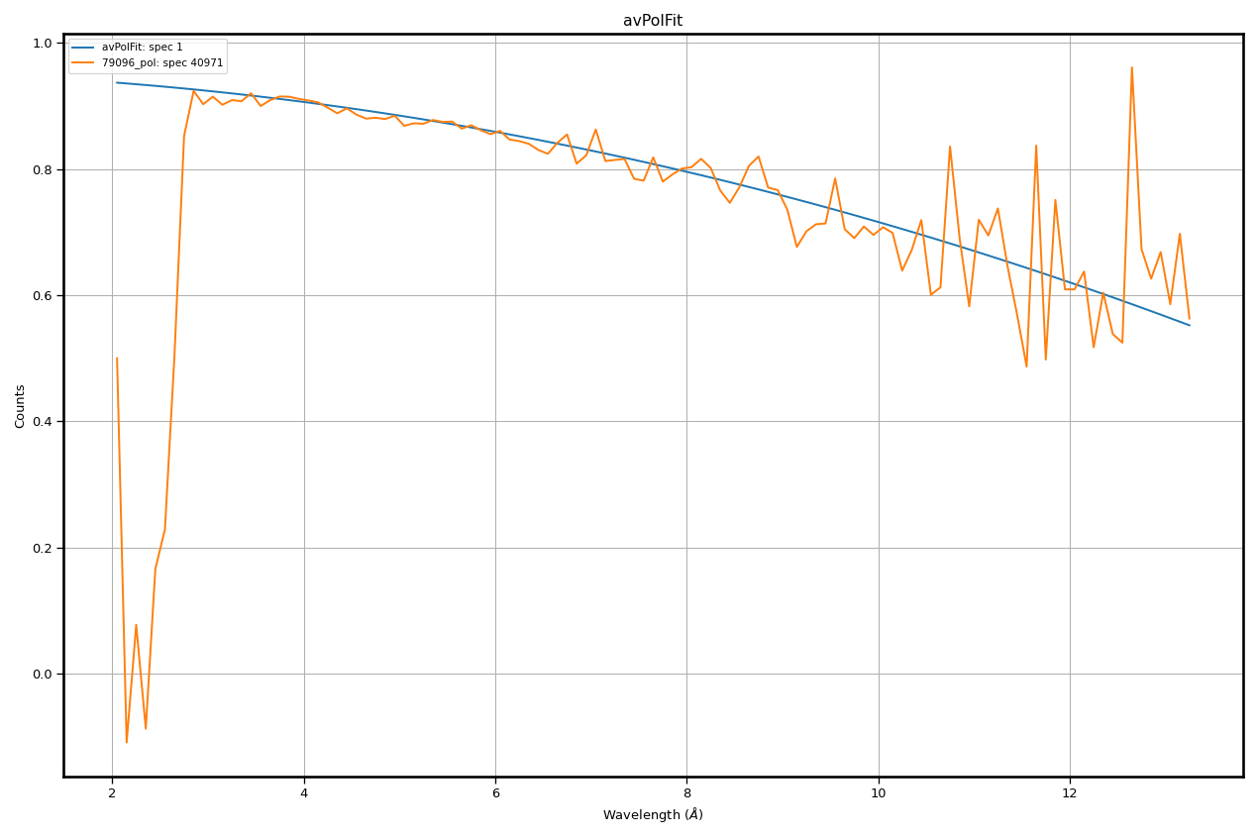

Individual data set comparison at constant momentum transfer.

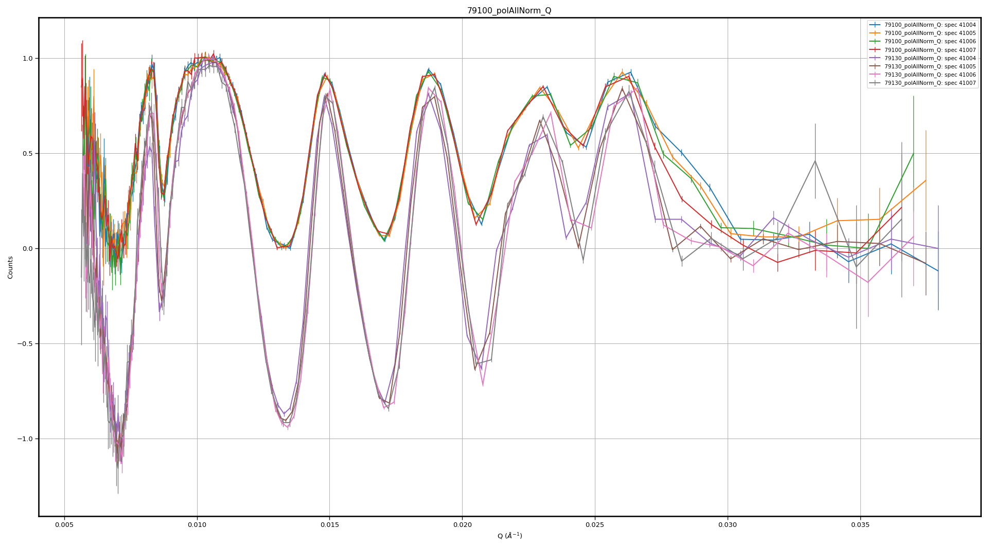

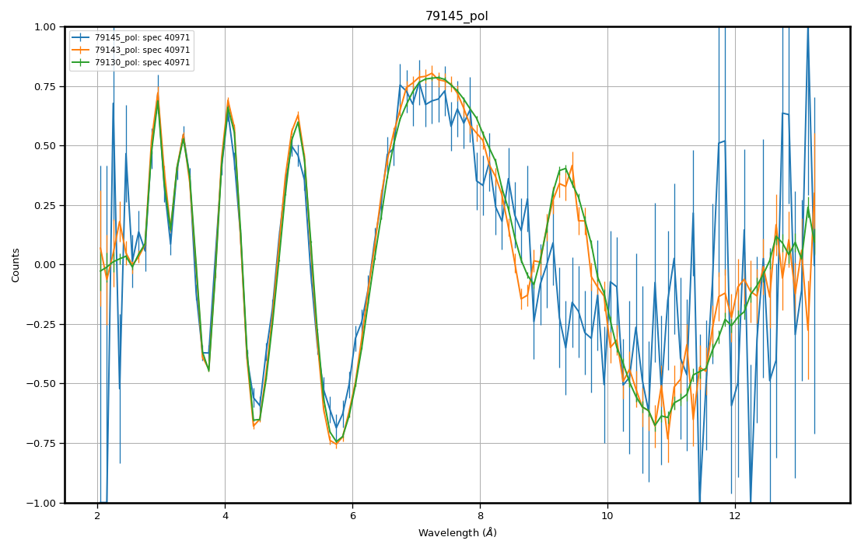

Goos-Hanchen shift at 9 Angstroms, where the peaks go kaflooey

Note that the grating position whether it is before or after the sample is not correct in the run title

Runs 79130 – 79142 No grating

Runs 79143 – 79144 Grating is **after** sample

Runs 79145 – 79159 Grating is **before** the sample

Runs 79160 – 79164 Grating is **after** sample

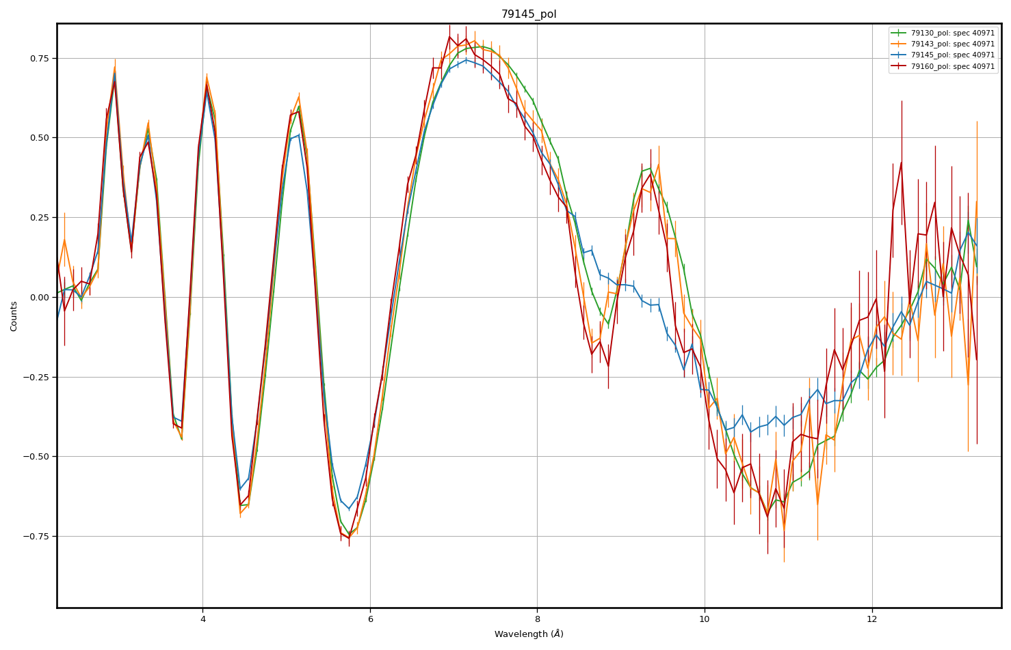

Note: Victor gets a better fit if the angle is .32 degrees instead of .35 degrees

Remeasuring P0 from blank, started realignment at 2:45 pm on Saturday

One hour blank check was good, moving the second arm angle now

5:10-Quick echo check, running blank over dinner after changing angle 57.78 -> .4 incident angle on the blank

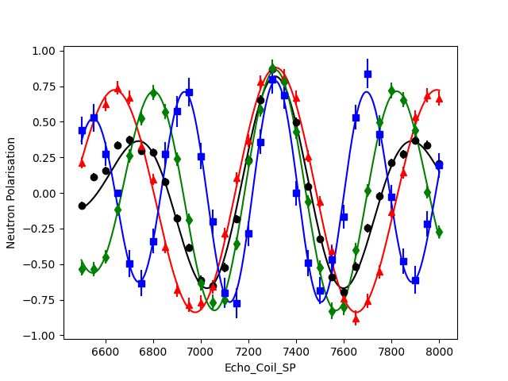

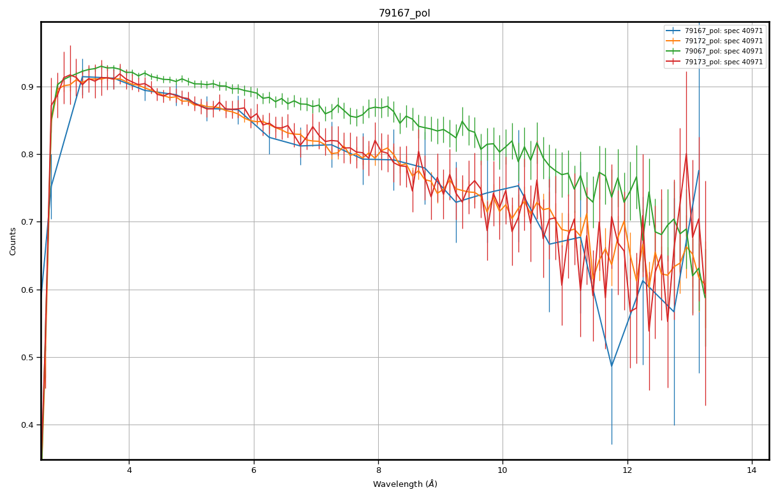

9:00 Saturday: Finished a total of 3 blank scans, seems to be completely consistent, even with the different incident angle P0 scans. Put the sample back in the beam, hopefully the feature will be pushed out to larger wavelengths